Q.1 What is Method Overloading: Enhancing Code

Readability

Method overloading allows you to define multiple methods with

the same name within a class, provided they have different

parameter lists. This feature significantly improves code

readability and reusability.

Why is it useful?

Improves code readability and organization.

Enables logically similar operations to share a name.

Key Rules:

Parameters must differ (count, type, or order).

Return type alone is not sufficient to overload.

It's a compile-time polymorphism feature.

int add(int a, int b) { return a + b; }

double add(double a, double b) { return a + b; }

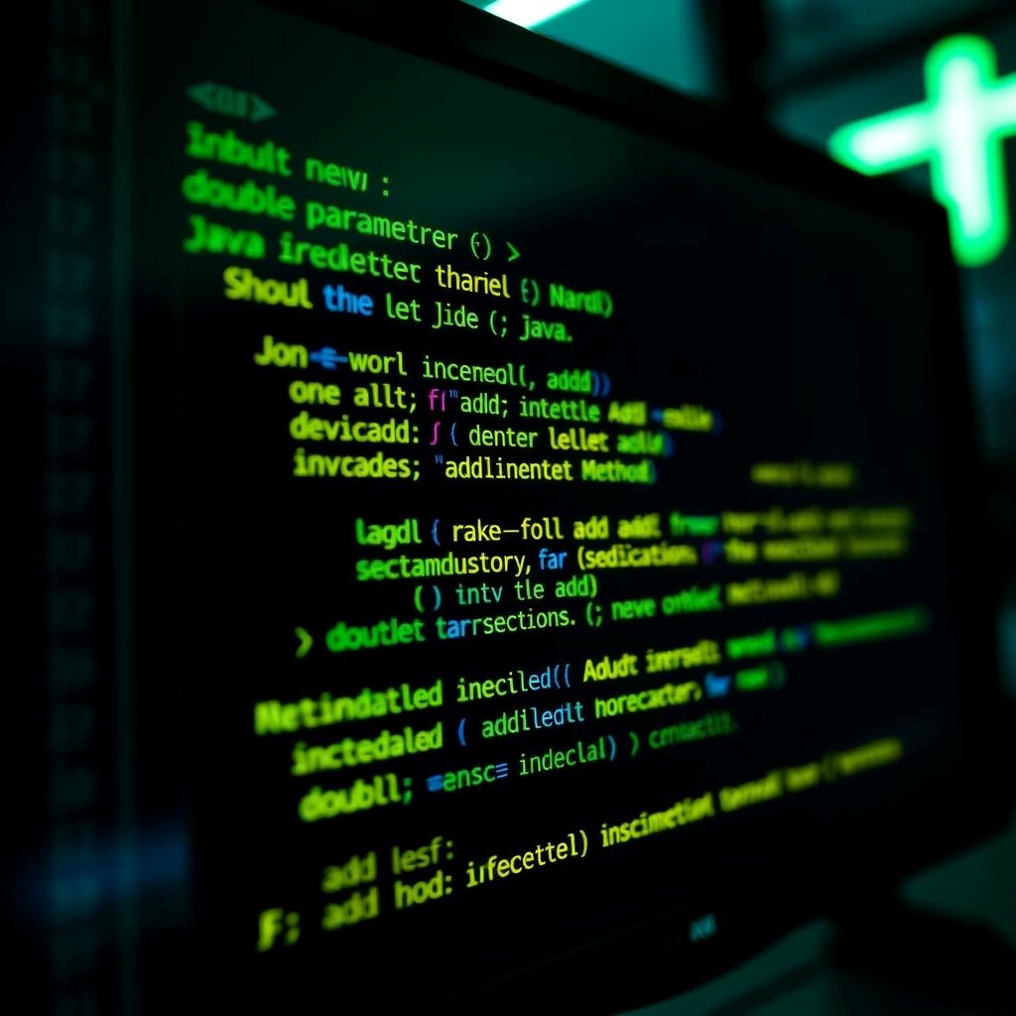

This example demonstrates how two

add

methods can coexist,

handling different data types seamlessly.

Q.2 Handling Divide-by-Zero Errors

Division by zero is an undefined mathematical operation and a common source of program crashes. Java provides mechanisms to

gracefully handle these situations, preventing unexpected application termination.

**Integer Division**

Attempting to divide integers by zero throws an

ArithmeticException

at runtime.

**Floating-Point Division**

Dividing floating-point numbers by zero results in

Infinity

or

NaN

(Not a Number), without an exception.

try {

int result = a / b;

}

catch (ArithmeticException e)

{

System.out.println("Cannot divide by zero!");

}



**Solutions for Safe Division**

**Conditional Check:**

Always validate the divisor before

performing division.

if (b == 0)

is your first line of defense.

**Exception Handling:**

Utilize

try-catch

blocks to elegantly

manage

ArithmeticException

for integer division.

The code snippet shows a robust way to prevent crashes by

catching the exception.

Q.3Understanding

= =

vs

.equ

a

ls()

A crucial distinction in Java, especially when working with objects, is understanding how to compare values correctly.

The

==

Operator

**Primitives:**

Compares the actual values (e.g.,

int

,

char

).

**Objects:**

Compares memory addresses (references),

checking if two variables point to the exact same object in

memory.

The

.equalss

Method

**Objects:**

Compares the content or logical equivalence of

objects.

**Customization:**

Can (and often should) be overridden in

user-defined classes to define what "equality" means for

your objects.

String s1 = new String("hello");

String s2 = new String("hello");

System.out.println(s1 == s2); // false (different objects)

System.out.println(s1.equals(s2)); // true (same content)

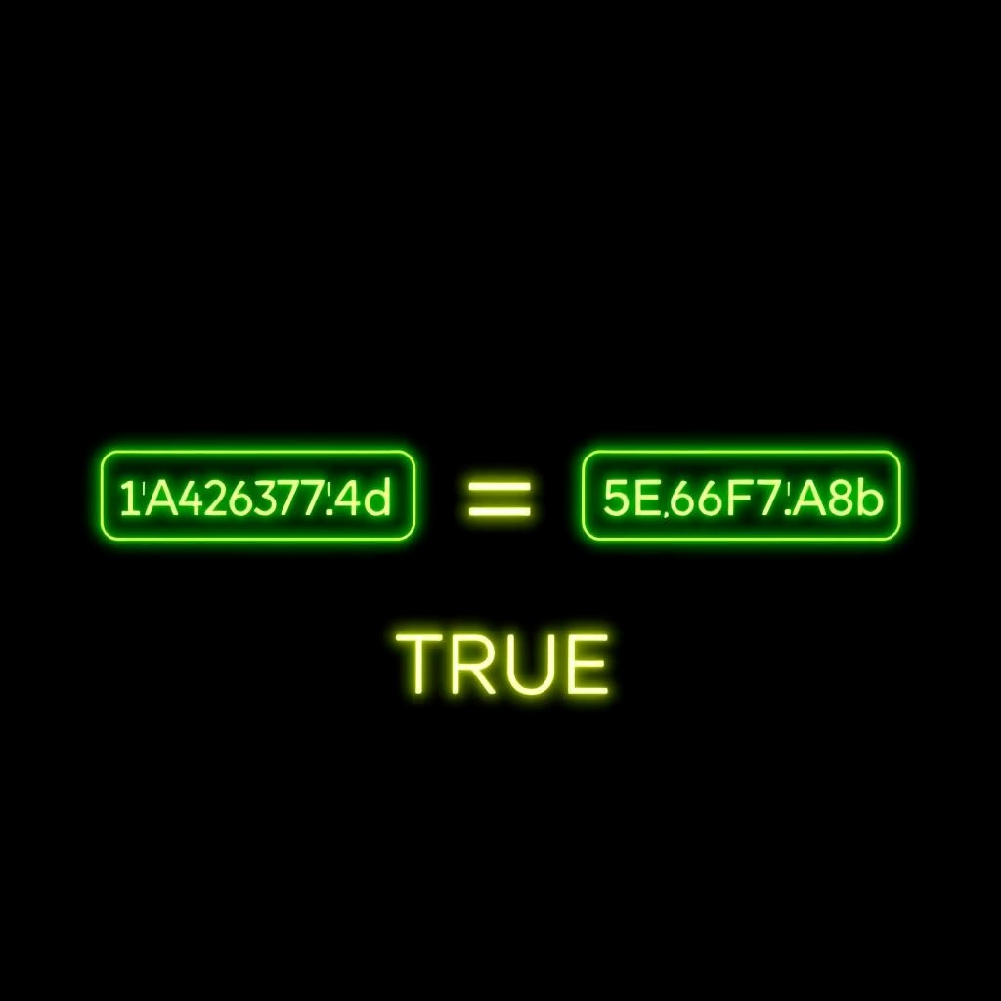

The example vividly illustrates how

s1

and

s2

, though containing

the same string "hello", are distinct objects in memory.

Q.4 Data types: Primitive Data Types

Java's eight primitive data types are the fundamental building blocks for storing various kinds of data, from simple numbers to true/false

values.

1

byte (1 byte)

Holds small integers (-128 to 127).

2

short (2 bytes)

Larger integers than byte.

3

int (4 bytes)

The most commonly used integer type.

4

long (8 bytes)

For very large integer values.

5

float (4 bytes)

Single-precision floating-point numbers.

6

double (8 bytes)

Double-precision floating-point, for higher accuracy.

7

char (2 bytes)

A single Unicode character.

8

boolean (1 byte)

Represents true or false values.

Choosing the right data type is crucial for efficient memory usage and correct program logic. They are declared directly and store their

values in memory.



Q.5 Scanner Class: Your Gateway to Input

The

Scanner

class, part of the

java.util

package, is an

indispensable tool for reading input in Java. It can parse primitive

types and strings from various sources.

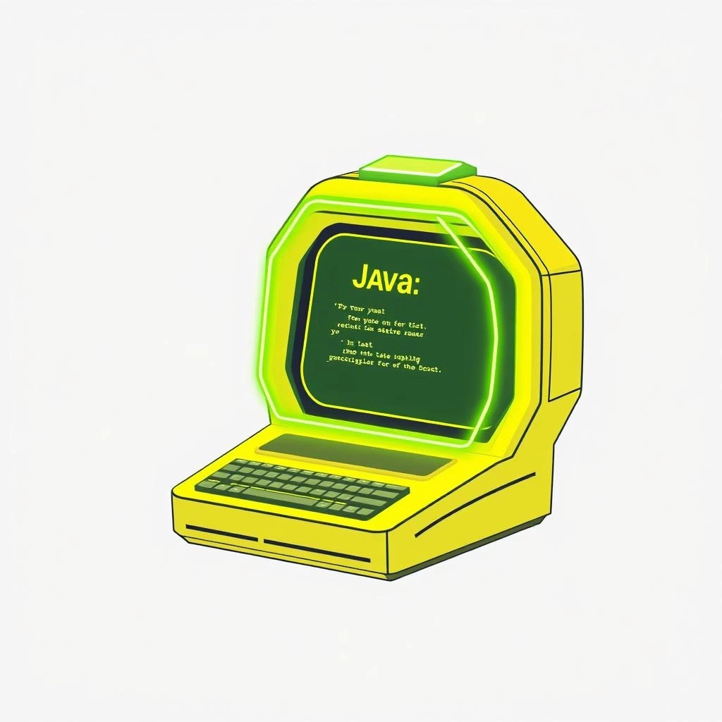

Keyboard Input

Commonly used to read user input from the console (

System.in

).

File & String Input

Can also read data from files or even directly from

String

objects.

Common Methods:

nextInt()

: Reads an integer.

nextDouble()

: Reads a double.

nextLine()

: Reads an entire line of text.

next()

: Reads a single word/token.

Scanner sc = new Scanner(System.in);

System.out.print("Enter your age: ");

int age = sc.nextInt();

sc.nextLine(); // Consume the leftover newline

System.out.print("Enter your name: ");

String name = sc.nextLine();

System.out.println("Hello, " + name + "! You are " + age + " years old.");

sc.close();

Q.6 Loops: Mastering Repetitive Tasks

Loops are fundamental control structures that allow a block of code to execute repeatedly until a specified condition is met. They are

essential for automating tasks and processing collections of data.

Purpose of Loops

Eliminate repetitive code, promoting efficiency.

Automate tasks such as calculations or array traversals.

Types of Loops in Java

**for loop:**

Ideal when the number of iterations is known in

advance.

**while loop:**

Executes as long as a condition remains true

(

unknown iterations

).

**do-while loop:**

Guarantees execution at least once, then

checks condition.

**for-each loop:**

Simplified iteration over arrays and

collections.

This

for

loop prints numbers from 1 to 5, a classic example of

iterating a known number of times.



for(int i=1; i<=5; i++) {

System.out.println(i);

}

Q.7 Loop Comparison:

while

vs.

for

While both

while

and

for

loops achieve repetition, their structures and typical use cases differ.

Unknown iterations, condition-based

Known iterations, counter-controlled

Use Case

Syntax Style

while (condition) { ... }

for (init; condition; update) { ... }

Execution Flow

Checks condition, then executes body

Init once, then check condition & update

// while loop example

int count = 0;

while (count < 3) {

System.out.println("While: " + count);

count++;

}

// for loop example

for (int i = 0; i < 3; i++) {

System.out.println("For: " + i);

}

Choose the loop that best fits the logic of your program for clarity and efficiency.

Q.8 & 9 JVM: The Heart of Java's Platform

Independence

The Java Virtual Machine (JVM) is a crucial component of the Java platform,

responsible for executing Java bytecode. It's the reason Java is so portable.

Bytecode Interpreter

Translates Java bytecode into

machine-specific code.

Memory Management

Includes a Garbage Collector for

automatic memory cleanup.

Ensures Portability

Allows Java to run on any device with a compatible JVM (Write Once, Run

Anywhere).

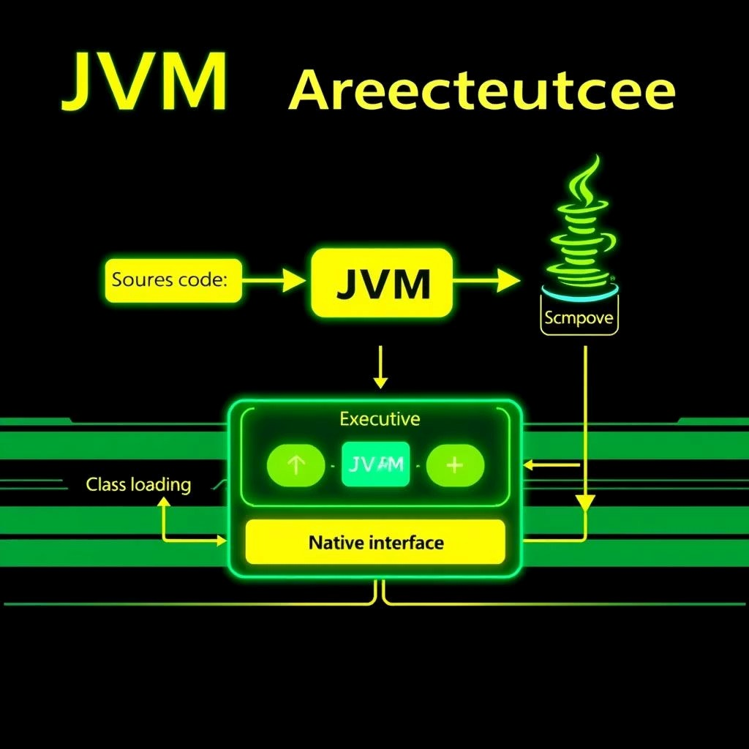

The JVM Workflow:

.java Source

Compilation

.class Bytecode

JVM Execution

Machine Code



Q.10 Debugging in Java:

Finding and Fixing

Errors

Debugging is an indispensable skill for any programmer, involving the process

of identifying, analyzing, and resolving defects or errors within software.

Print Statements

Simple yet effective: use

System.out.println()

to trace variable values and

execution flow.

IDE Debuggers

Powerful tools in IDEs (Eclipse, IntelliJ) for setting breakpoints, stepping

through code, and inspecting states.

Stack Trace Analysis

Learn to read error messages, which pinpoint the exact location and type of

exception.

Exception Handling

Implement

try-catch

blocks to manage runtime errors gracefully, preventing

crashes.

"The most effective debugging tool is still careful thought, coupled with

judiciously placed print statements."